**There is a error. I cant delete PointSnake class. It need not to exist.**

**Classes**

The classes are same with Project 1 classes. Just herbivore is changed as Snake.

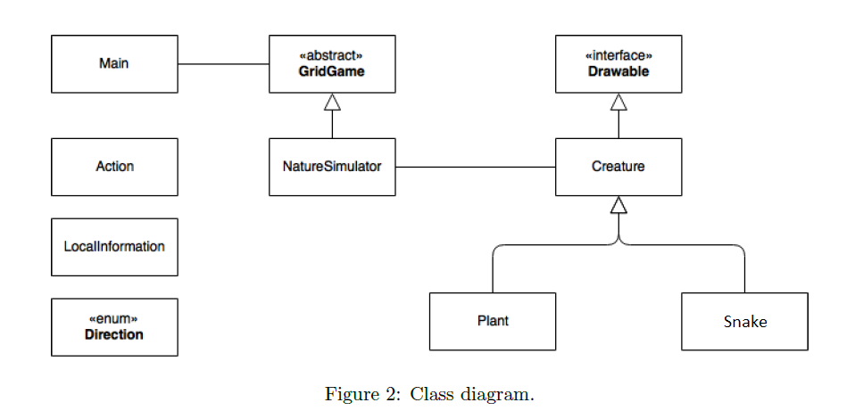

Snake is made from snake objects. There is a head(whose previous=null) and all snake is kept in <ArrayList>snakeBody. Every object holds the whole snake with snakeBody list. Actions are made by head meaning objects whose previous!=null does not act.

NatureSimulator class works same. Every creature chooses action, except now only head chooses action. Plant does not choose action as well.

Snake AI looks if it can eat the food,if not moves in the direction of food, if not moves to a random direction, if not it stays.

When snake eats the food it moves to its location and adds a new snake object to tail.

When it is going to divide into 2 it creates two snakes by old snake’s snake objects. All previouses and snakeBody s are created anew. Tail and old head are new heads.

İf food is eaten that round all other snakes stays, and food is created to a random empty location at the beginning of the next round.

Food is green

Snake’s head is blue, then rest is red, far snake objects from the head are lighter.

Running the code is like in Project 1. Snake and food needs to be added.

Example creates a snake of size 4 at location {(1,1),(2,1),(3,1),(4,1)} head is (1,1)

//Creates snakes, and snakes' bodies and add them

Snake[] snake= new Snake[4];

for(int i=0;i<4;i++) {

snake[i]=new Snake(1+i,1);

}

for(int i=0;i<3;i++)

snake[i+1].setPrev(snake[i]);

for(int i =0;i<4;i++) {

for(int j=0;j<4;j++)

snake[i].snakeBody.add(snake[j]);

game.addCreature(snake[i]);

}

//Adds food

game.addFood();

// Create application window that contains the game panel

ApplicationWindow window = new ApplicationWindow (game.getGamePanel());

window.getFrame().setVisible(true);

// Start game

game.start();